**Lab Report**  [**Embedded Systems-I (Spring-2024)**](https://classroom.google.com/u/1/c/NjUwNzc1MjExODgx)

# **Lab 1 Task**

# 



**Submitted By :** **2022-MC-58 Haseeb-ul-Hassan**

**Submitted To :** **Ms.Shujat Ali**

**Department Of Mechatronics And Control Engineering University Of Engineering And Technology, Lahore.**

**25th January 2024**

.



**INTRODUCTION**

Google Home Mini is a compact smart speaker that works with Google Assistant, a virtual assistant that can answer questions, control smart devices, play music, and more. Google Home Mini can be used to access various Google services, such as YouTube, Google Photos, Google Calendar, and Google Maps. [Google Home Mini can also connect to other speakers and devices that support Chromecast or Bluetooth1](https://www.lifewire.com/what-is-a-google-home-mini-and-how-does-it-work-4801920)[2](https://blog.google/products/home/google-home-mini-has-arrivedheres-what-you-can-do-it/).

Some of the features of Google Home Mini are:

* [Voice Match: Google Home Mini can recognize up to six different voices and provide personalized assistance for each user2](https://blog.google/products/home/google-home-mini-has-arrivedheres-what-you-can-do-it/).
* [Night Mode: Google Home Mini can adjust its volume and brightness according to the time of day or your preferences2](https://blog.google/products/home/google-home-mini-has-arrivedheres-what-you-can-do-it/).
* [Default TV or Speaker: Google Home Mini can automatically play audio or video on a designated Chromecast-connected TV or speaker group2](https://blog.google/products/home/google-home-mini-has-arrivedheres-what-you-can-do-it/).
* [Find My Phone: Google Home Mini can ring your Android or iPhone, even if it’s on silent mode2](https://blog.google/products/home/google-home-mini-has-arrivedheres-what-you-can-do-it/).

[Google Home Mini is available in four colors: chalk, charcoal, coral, and aqua3](https://www.groovypost.com/howto/getting-started-google-home-mini-with-google-assistant/). [It costs $49 USD and can be purchased online or from various retailers2](https://blog.google/products/home/google-home-mini-has-arrivedheres-what-you-can-do-it/).

**product specifications**

Google Home Mini is a compact smart speaker that works with Google Assistant, a virtual assistant that can answer questions, control smart devices, play music, and more. Google Home Mini can be used to access various Google services, such as YouTube, Google Photos, Google Calendar, and Google Maps. [Google Home Mini can also connect to other speakers and devices that support Chromecast or Bluetooth1](https://www.lifewire.com/what-is-a-google-home-mini-and-how-does-it-work-4801920)[2](https://blog.google/products/home/google-home-mini-has-arrivedheres-what-you-can-do-it/).

Some of the features of Google Home Mini are:

* [Voice Match: Google Home Mini can recognize up to six different voices and provide personalized assistance for each user2](https://blog.google/products/home/google-home-mini-has-arrivedheres-what-you-can-do-it/).
* [Night Mode: Google Home Mini can adjust its volume and brightness according to the time of day or your preferences2](https://blog.google/products/home/google-home-mini-has-arrivedheres-what-you-can-do-it/).
* [Default TV or Speaker: Google Home Mini can automatically play audio or video on a designated Chromecast-connected TV or speaker group2](https://blog.google/products/home/google-home-mini-has-arrivedheres-what-you-can-do-it/).
* [Find My Phone: Google Home Mini can ring your Android or iPhone, even if it’s on silent mode2](https://blog.google/products/home/google-home-mini-has-arrivedheres-what-you-can-do-it/).

[Google Home Mini is available in four colors: chalk, charcoal, coral, and aqua3](https://www.groovypost.com/howto/getting-started-google-home-mini-with-google-assistant/). [It costs $49 USD and can be purchased online or from various retailers2](https://blog.google/products/home/google-home-mini-has-arrivedheres-what-you-can-do-it/).

**APPLICATIONS**

Google Home Mini has many applications that can make your life easier and more fun. You can use it to:

* Ask questions and get answers from Google
* Control your smart home devices with your voice
* Play music, podcasts, audiobooks, and more
* Set timers, alarms, reminders, and calendars
* Make hands-free calls and send messages
* Play games and trivia with your family and friends
* Learn new languages and skills
* And much more!

[You can explore more applications of Google Home Mini by downloading the Google Home app1](https://home.google.com/intl/fr_fr/get-app/)[2](https://home.google.com/get-app/)[or by visiting the official website3](https://blog.google/products/home/google-home-mini-has-arrivedheres-what-you-can-do-it/). You can also ask me to suggest some things you can do with Google Home Mini, such as “Hey Google, what can you do?” or “Hey Google, tell me a joke.”

**First Impressions**

**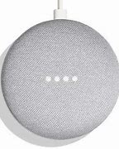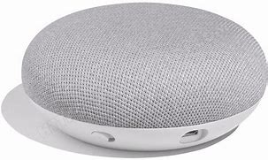**

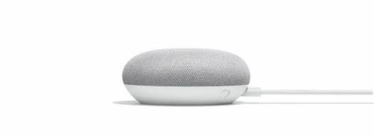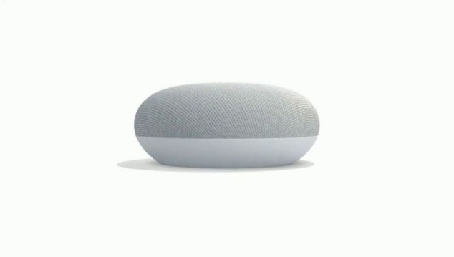

In this teardown, we inspect the guts of Google’s voice-activated home assistant, the Google Home Mini as well as which microprocessor is used .

Being a newbie to voice-activated home assistant devices, I wasn’t quite sure what to expect during the unboxing of the [Google Home Mini](https://www.bestbuy.com/site/google-home-mini-chalk/6082194.p?skuId=6082194). I must admit that after removing the chalk-colored voice assistant from its packaging, I said out loud: “This is it?” That's how small it is—it measures only 3.85” in diameter and 1.65” in height.

Nonetheless, it did feel like a solidly-built piece of technology: no loose speaker cover, no flimsy plastic pieces, and no metal/plastic pieces rolling around on the inside as I completed my visual inspection.

The first step of the disassembly process was to locate the hidden screws that held the unit together.

***Google Home Mini***

**A Hunt for the Screws**

After prying, pulling, and twisting the device with the hopes of locating those darn screws, I realized they must be hidden under the brightly-colored rubber-like base plate covering. Removing this rubberized cover was not trivial—at least, not until it met my heat gun.

After warming up the rubber cover a bit (actually, I had to get it quite hot), I was able to peel it off. If you’re worried about this rubber cover coming off with years of use and abuse, don't. It’s not going anywhere.

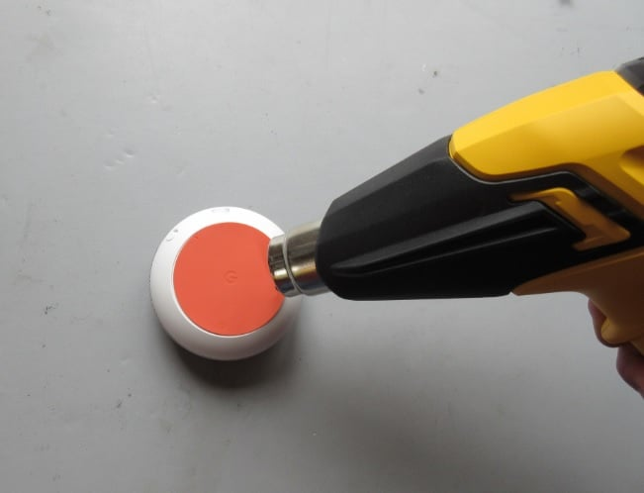

***A heat gun was required for removing the rubber base plate covering.***

**Removing the Screws and Viewing the Components**

Once the rubber base plate covering was removed, four Torx screws were exposed.

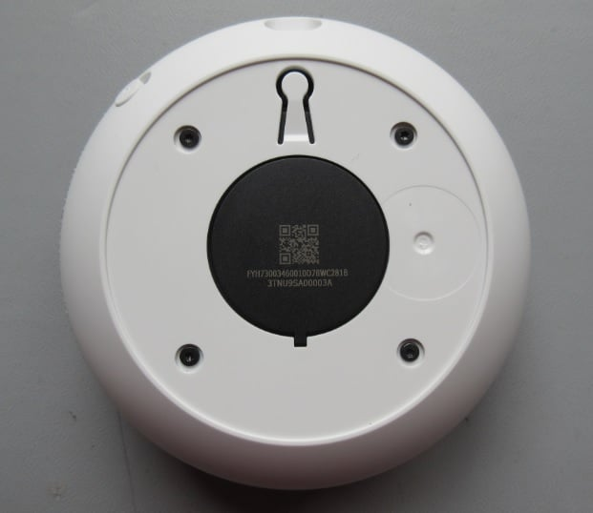

***Four Torx screws reside under the rubber base plate covering.***

After removing these four screws and then subsequently removing the white plastic cover, four more screws were observed holding the speaker housing in place. Also in view was a simple PCB which held the USB connector and a flex circuit (used for bringing power to the internal electrical components). Using a flex circuit is a much cleaner, and perhaps more durable, design approach when compared to using simple wires or a cable.

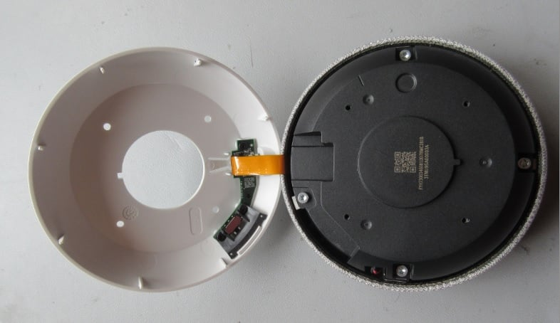

***Simple PCB and flex circuit, and the speaker housing.***

With the speaker housing removed, we can see a cone-shaped metal/plastic hybrid plate and, of course, the speaker itself.

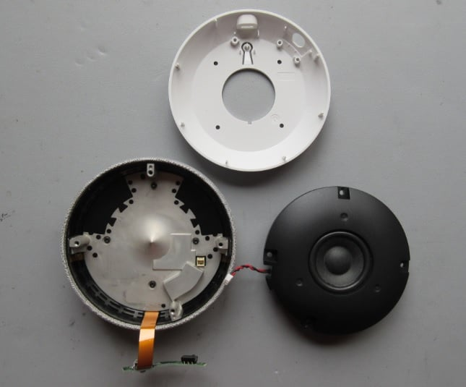

***Cone shaped metal-plastic plate and the speaker.***

The lone speaker (see images below), which looks to be either a [full-range or midrange speaker](https://www.allaboutcircuits.com/technical-articles/introduction-audio-electronics-sound-microphones-speakers-amplifiers/), has a fairly large magnet on it. As you can see, the speaker was contained inside its plastic-welded enclosure. Sealing the speaker enclosure in this manner increases the overall sound quality of this rather small speaker.

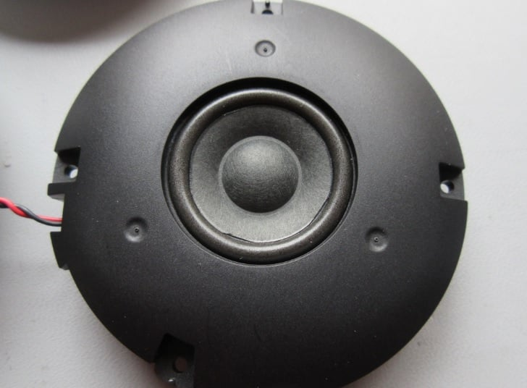

***The speaker's cone.***

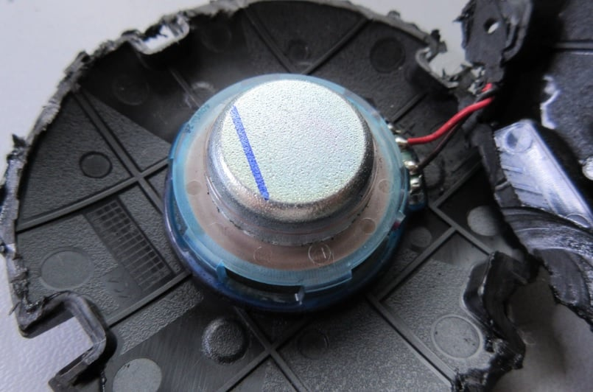

***The speaker’s magnet.***

**Metal/Plastic Hybrid Cone-Shaped Plate**

The metal/plastic hybrid cone-shaped plate is designed to redirect the sound waves with the intent of increasing the sound quality of the device. The reason for having the two strategically-located black plastic pieces is that they allow for the RF signals (Wi-Fi and Bluetooth) to reach the device’s antennas.

And you might ask, “why not use plastic for the entire plate instead of using part plastic and part metal?” The answer is heat dissipation/thermal relief (see images below).

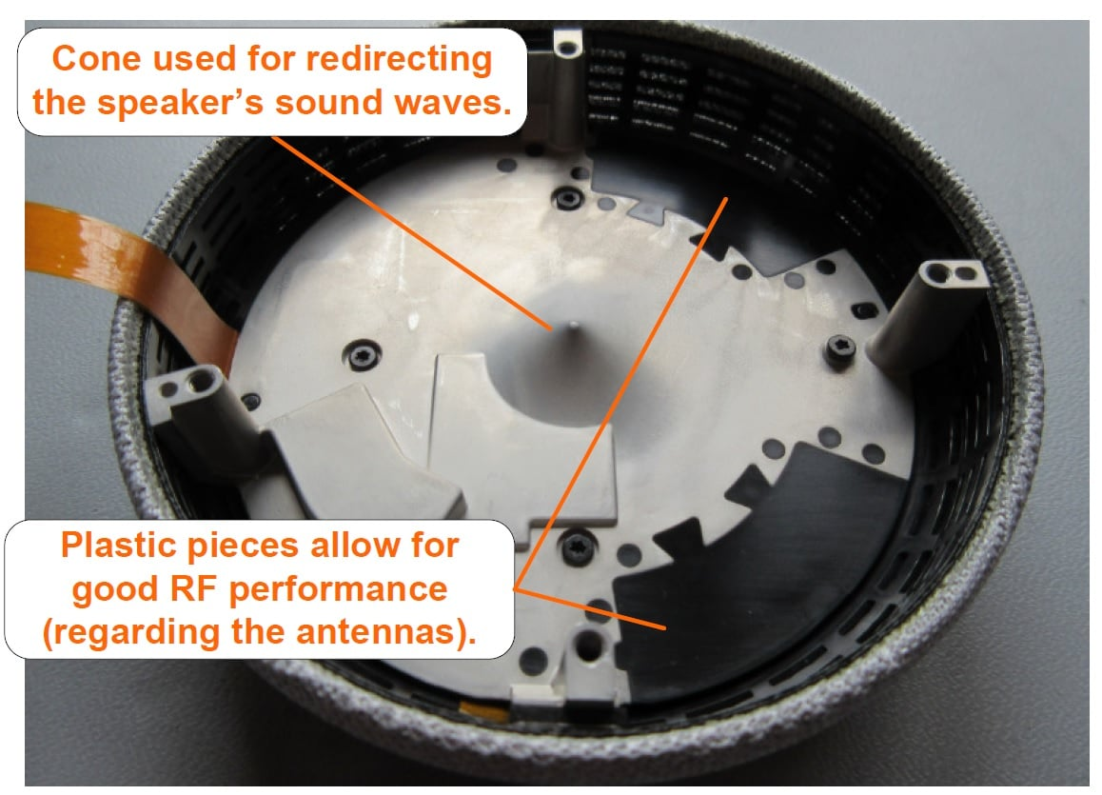

***Metal/plastic plate with a sound wave redirecting cone.***

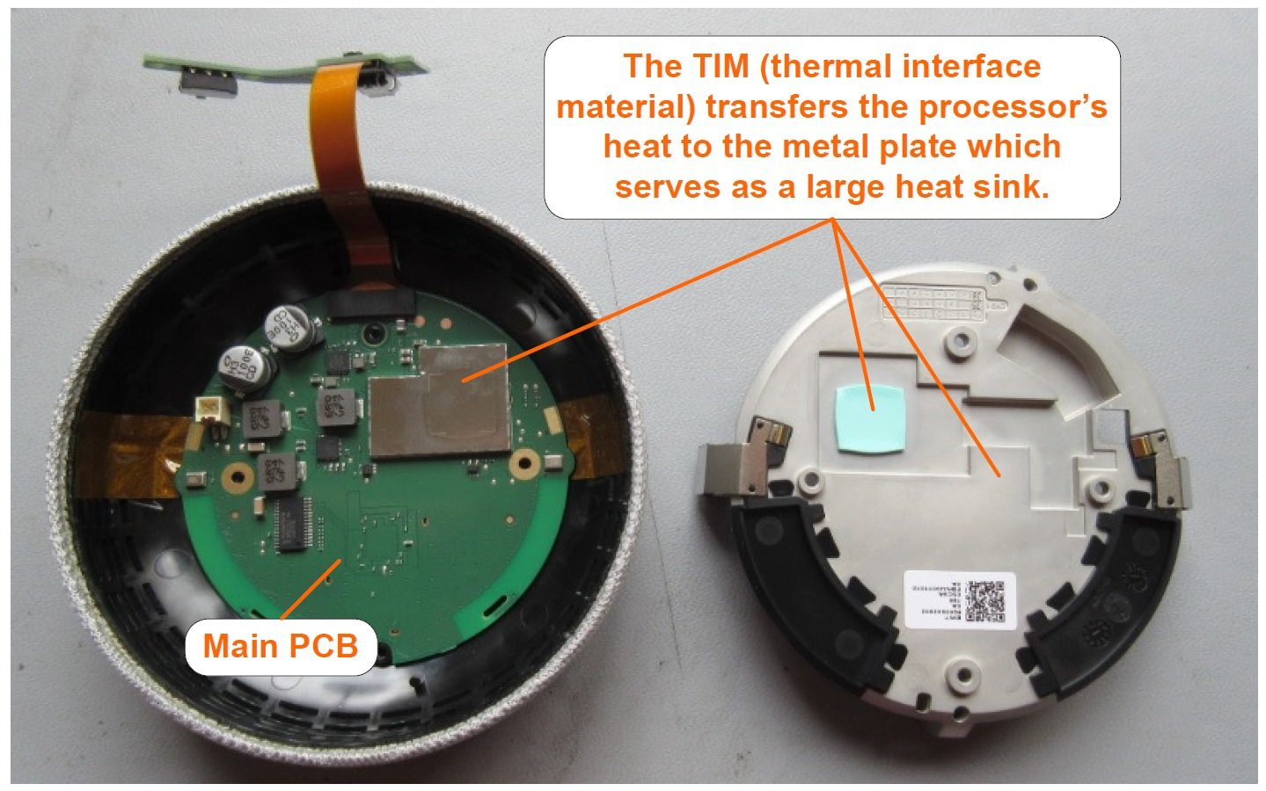

***Metal/plastic plate serves as a heat sink.***

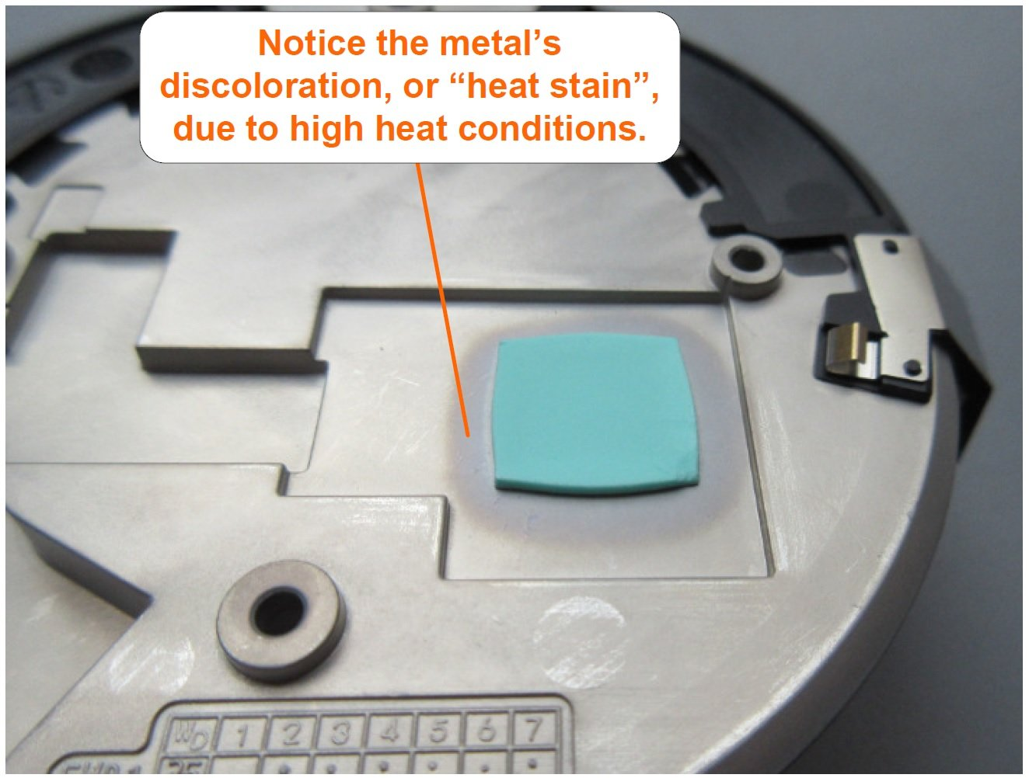

***Metal discoloration due to heat.***

**The Main PCB**

As can be seen in the image below, the main PCB connects to the *volume up* and *volume down* capacitive touch sensors using gold plated contacts (on the sheet metal parts) and a gold-plated [PCB surface finishing](https://www.allaboutcircuits.com/technical-articles/pcb-copper-trace-finish-materials-plating-methods/).

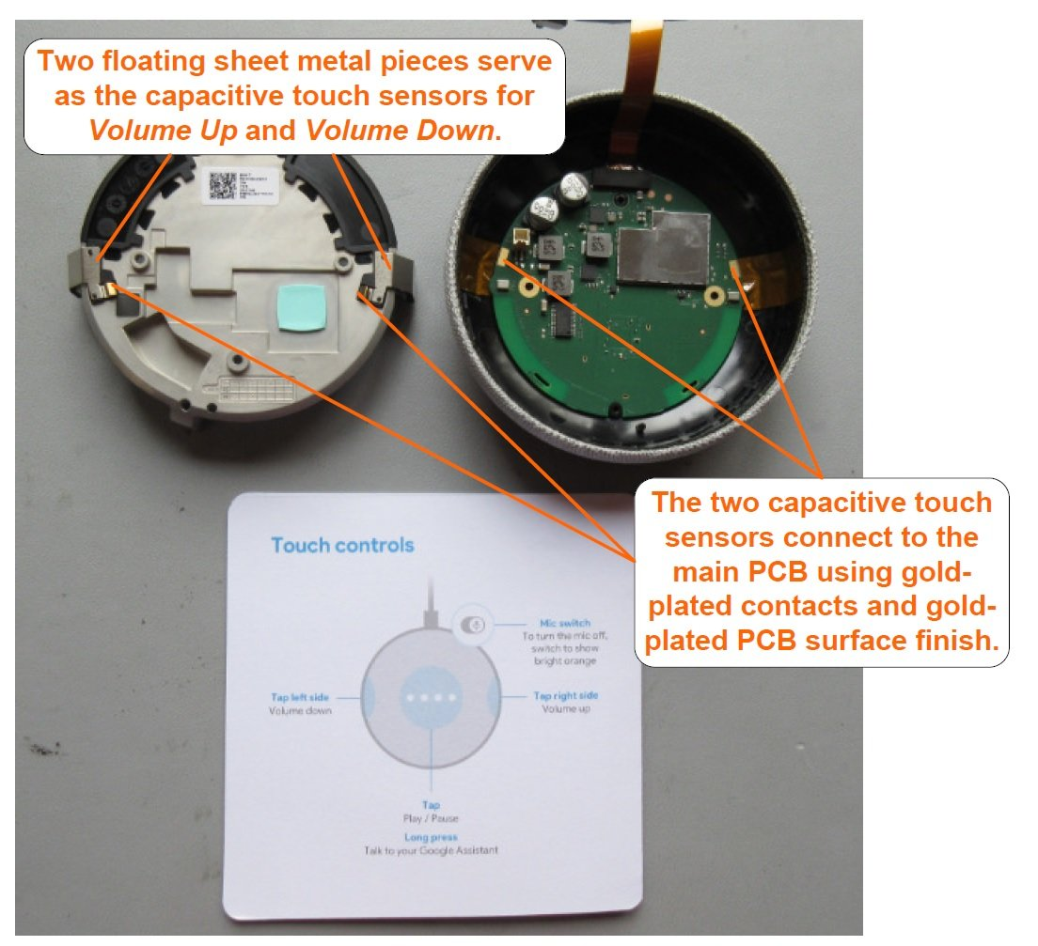

***Capacitive touch controls and the main PCB.***

The main PCB looks to be professionally designed and manufactured. To help keep costs down, this board is limited to a two-layer design (i.e., there are no internal layers). However, gold plating is used in some critical areas to help with long-term use and reliability, despite resulting in an increase in board cost.

The image below calls out the primary components used on this side of the PCB. Note that the main processor uses an EMI shielding box (to help reduce EMI noise) and also uses TIM (thermal interface material) to transfer its heat to the EMI shielding box, which, as we’ve already seen, uses TIM to transfer the heat to the metal plate.

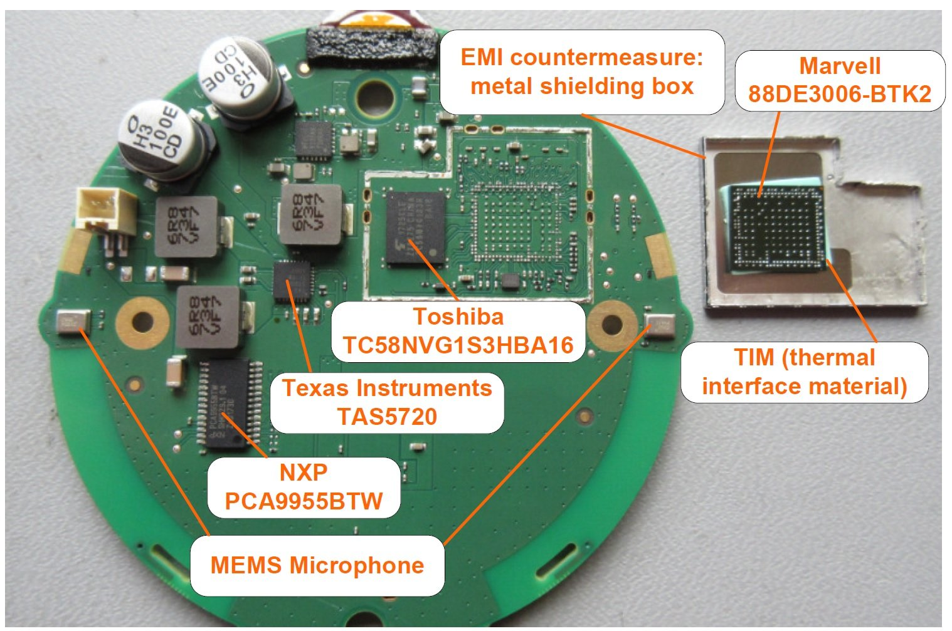

***Main PCB: front side and primary components.***

* **Main processor:** Marvell [88DE3006-BTK2](http://www.marvell.com/company/news/pressDetail.do?releaseID=7116). Also referred to as [Marvell’s ARMADA® 1500 Mini Plus](https://www.synaptics.com/products/multimedia-solutions).
* **MEMS microphones:** Part marking: S19548562. No additional information could be found.
* **Memory (EEPROM):** Toshiba [TC58NVG1S3HBA16](http://www.mouser.com/ds/2/877/TC58NVG1S3HBAI6_datasheet_en_20130118-1148524.pdf)
* **Audio amplifier:** Texas Instruments [TAS5720](https://www.allaboutcircuits.com/electronic-components/datasheet/TAS5720LRSMT-Texas-Instruments/)
* **LED driver:** NXP [PCA9955BTW](https://www.allaboutcircuits.com/electronic-components/datasheet/PCA9955BTWJ-NXP-Semiconductors/)

The EMI metal shielding box looks to be perfectly (i.e., no gaps) soldered to the PCB (see image below). Such high-quality assembly and solder process allows the EMI shielding box to serve, as much as reasonably possible, as a Faraday cage.

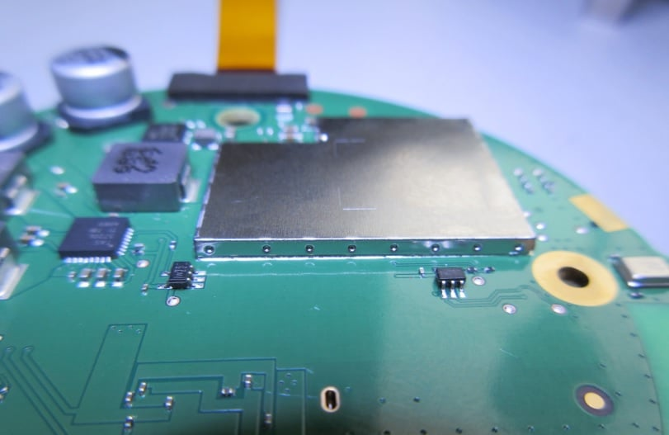

***The EMI shielding box is perfectly soldered to the PCB (i.e., there are no gaps) creating an ideal Faraday cage.***

The back side of the PCB and its primary components can be seen in the figure below. This side uses two EMI shielding boxes, and both are perfectly soldered to the PCB. However, to gain access to the components underneath the shielding boxes, both boxes have been removed.

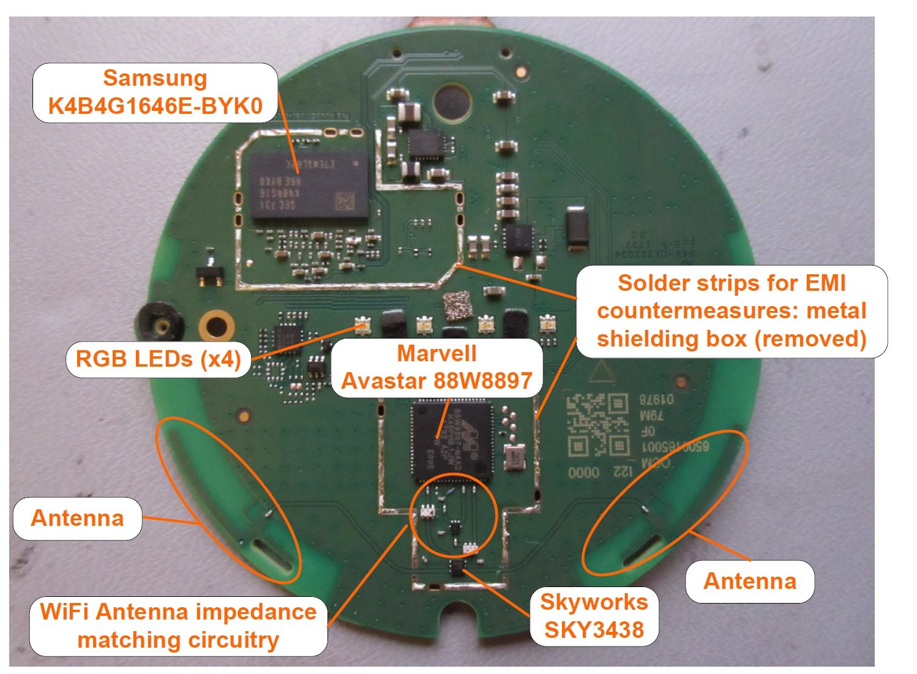

***Main PCB: backside and primary components.***

* **Wi-Fi combination radio chip:** [Marvall Avastar 88W8897](http://www.marvell.com/wireless/assets/Marvell_Avastar_88W8897_SoC-003_PB.pdf" \t "_blank)(PDF). Additional information can be found [here](https://www.marvell.com/wireless/avastar/88W8897/).
* **Memory (DRAM):**Samsung [K4B4G1646E-BYK0](http://www.samsung.com/semiconductor/global/file/product/2016/08/DS_K4B4G1646E_BY_M_Rev1_11-0.pdf)(PDF)
* **Antenna switch:**Skyworks SKY3438. No datasheet could be found, but it appears to be similar to [this one](http://www.skyworksinc.com/uploads/documents/201407C.pdf)(PDF).

**Summary**

By all measures, the [Google Home Mini](https://www.bestbuy.com/site/google-home-mini-chalk/6082194.p?skuId=6082194) appears to be a professionally designed and expertly assembled voice-activated home assistance device. Although it is a rather small device, it definitely delivers when it comes to technology features.

|  |  |
| --- | --- |
| **Model** | **Home** |
| **Mini** |
| **Release date** | 19-Oct-17 |
|
| **Launch price** | US$49 |
|
| **Processor** | [Marvell](https://en.wikipedia.org/wiki/Marvell_Technology_Group) |
| 88DE3006 |
| Armada |
| 1500 Mini Plus |
| 1.2 GHz dual-core |
| [ARM](https://en.wikipedia.org/wiki/ARM_Cortex-A7) |
| [Cortex-A7](https://en.wikipedia.org/wiki/ARM_Cortex-A7) |
|  |
| **Display** | — |
|
|
| **Built-in camera** | — |
| **Bluetooth version supported**[2] | Bluetooth 4.1 |
|
| **Dimensions**[2] | 3.86 in |
| (98 mm) diameter, |
| 1.65 in |
| (42 mm) high |
|  |
|  |
| **Weight**[2] | 173 g (0.38 lb) |
|
| **Matter support**[70] | yes |

[The **Cortex-A17** is a **RISC** (Reduced Instruction Set Computing) processor core designed by ARM Holdings 1](https://en.wikipedia.org/wiki/ARM_Cortex-A17). [It is capable of dual-issue and features a 8-stage integer pipeline](https://en.wikipedia.org/wiki/ARM_Cortex-A17)[1](https://en.wikipedia.org/wiki/ARM_Cortex-A17). [The clock speed of the Cortex-A17 processor is **1.2 GHz** 1](https://en.wikipedia.org/wiki/ARM_Cortex-A17).

[Regarding your question about the computer architecture, the Cortex-A17 processor is based on the **von Neumann architecture** 2](https://stackoverflow.com/questions/30558834/how-can-i-tell-whether-my-computer-is-harvard-or-von-neumann-architecture)[1](https://en.wikipedia.org/wiki/ARM_Cortex-A17).

**References**

**Webites**

[www.google.com](http://www.google.com)

[www.bing.com](http://www.bing.com)

[www.alldatasheet.com](http://www.alldatasheet.com)

<https://www.allaboutcircuits.com/news/teardown-tuesday-google-home-mini/>

<https://www.ifixit.com/Teardown/Google+Home+Mini+Teardown/102264>

<https://www.lifewire.com/what-is-a-google-home-mini-and-how-does-it-work-4801920>

<https://assistant.google.com/>

<https://youtu.be/gzrrsJUpqRg?si=Mktc6vMcFsEgsha4>

**Ai’s**

Microsoft copilot